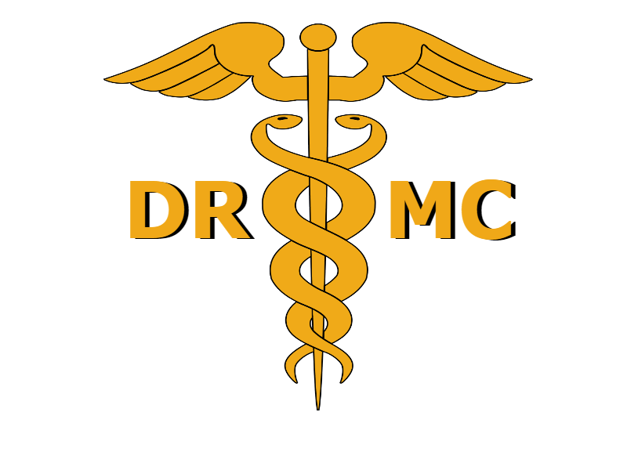
Medical Club Junior Officer Elections Application
Due to drhsmed@gmail.com on February 28th.
The Junior Officer Elections for the 2021-2022 school year will be held on March 1st, 2022.
You MUST be present to give a speech on this day in order to run.
Each candidate will NOT be running for a specific officer position. Instead, the top 5 candidates with the most votes will be elected as new junior officers. To obtain votes, each candidate will give a short speech on March 1st. Votes will be open until March 8th and the new officers will be announced on Schoology. Your completed application will be available for the members to see! This application, along with your speech, will be used by members to decide who to vote for.

The elected junior officers will be joining the current officers in planning any future meetings.

Name:

Grade:

School Email:

Why you think you are a good candidate?

**Please follow the required outline below.

Hello, my name is _____(full name)_______ and I am a ______(freshman, sophomore, etc.)__________. I am running for the position of Junior officer for the 2022-2023 school year. I feel like I would be a good fit for this role because_____*The rest of the speech is yours to write however you want* (what would you do for the club? How would you improve it? How dedicated to the Medical club were you this year? Any comments? etc..)____(Transition to ending)____(Ending + any final notes).

